Jiajun Yu

Aug 22, 2021

Foundations of Programming, SQL

Assignment 07

GITHUB Link:

**SQL UDF, Scalar, Inline, and Multi-Statement Functions**

**Introduction**

In this paper, I will go over the questions about SQL UDF, Scalar, Inline, and Multi-Statement Functions

and will explain when we shall use those statements.

**1. Explain when you would use a SQL UDF.**

Definition

SQL UDF statement means user defined function and which is UDF in short by using Transact-SQL..

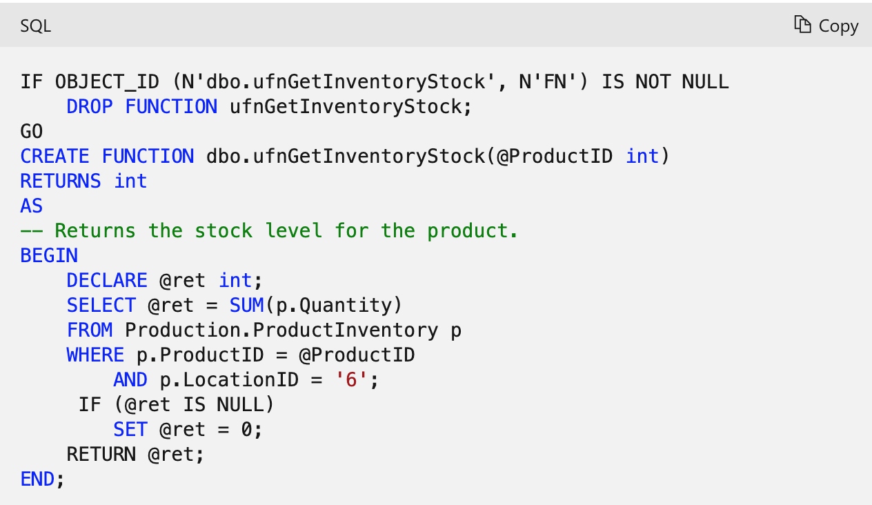

*Figure 1: screenshot from https://docs.microsoft.com/en-us/sql/relational-databases/user-defined-functions/create-user-defined-functions-database-engine?view=sql-server-ver15*

When to use a SQL UDF

A scalar valued UDF accepts parameters and can return a single atomic value. The main purpose is to use the objects stored in the database and avoid writing the same code over and over again.

* Store complex code in one structure
* Match test input parameters
* Don’t want to rewrite same code
* Do the changes to the code in one place and reflect the change at every place the function is used
* Need to calculate which will be repeated throughout the database

**2. Explain the differences between Scalar, Inline, and Multi-Statement Functions.**

Similarities

Scalar, Inline, and Multi-Statement Functions are three types of user defined functions. The main purpose of using those statements is to improve maintainability and code readability.

Difference

Scalar, Inline, and Multi-Statement Functions when we need to use them to return different values or results.

* The Scalar UDF usually is used to return one single value from input value. It works on each record independently. It always returns a single valued result.
* The Inline table valued function returns a variable of data type table with the value derived from one SELECT statement
* The Multi-statement table valued function returns a table variable as result of function actions. It returns a table and the table structure will be returned.

**Summary**

Overall, SQL UDF, Scalar, Inline, and Multi-Statement Functions are used to improve the maintainability and code readability of codes.